Name: Tausif Sadid

ID: 17101083

Assignment B

I have used rational rose, and with this I have designed the use case diagram for the wilderness weather station which I already did once in modelio. Diagram given below

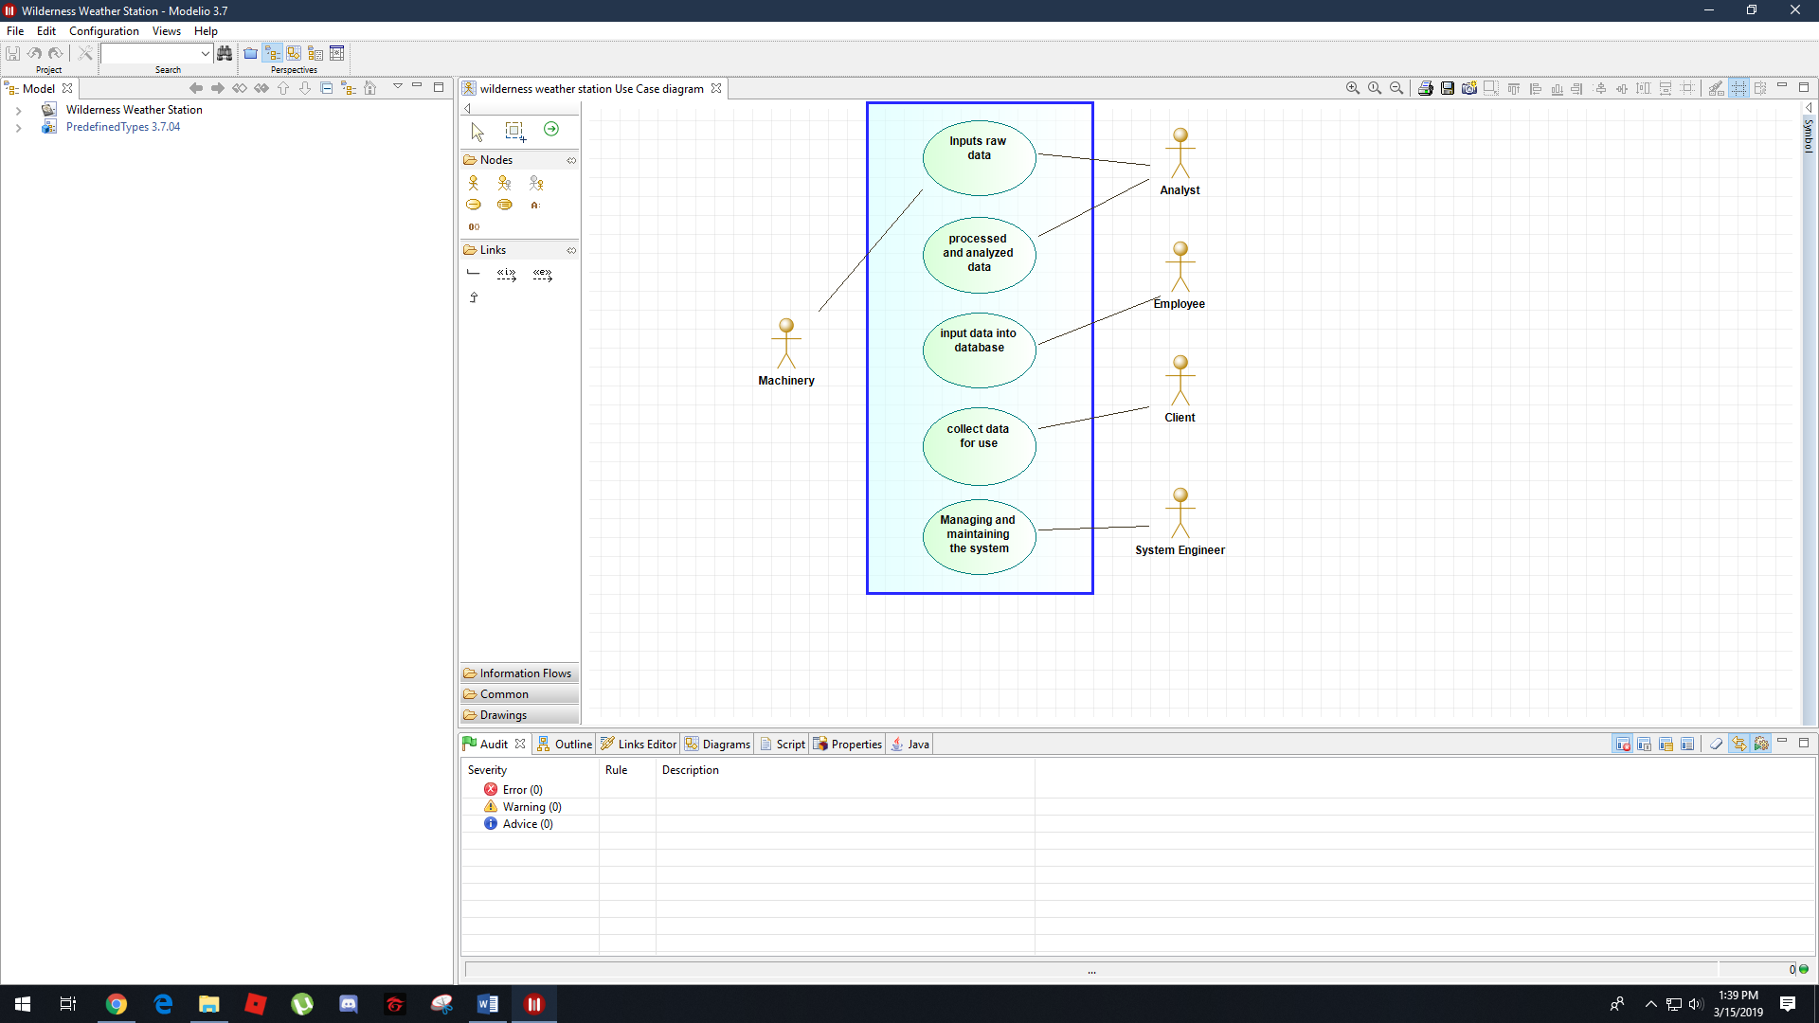

The software can be used to make different diagrams which can then be used to make programs. The software is made by IBM and is downloadable.

And the same model in rational rose looks like this:

